Below are instructions for Staff on best practices for troubleshooting the password reset email. The following instructions will give staff the tools they need to troubleshoot password reset issues.  
   
**For Staff:** As the new school year commences, many faculty and staff are busy with preparations, including logging back into TalentEd. Just like students don’t always retain information over the summer, sometimes teachers and staff forget login information.  
  
**Here are the steps to request a password reset email:**

1. Go to the TalentEd login page for your school district.  
2. Click the "**Forgot your password?**" link

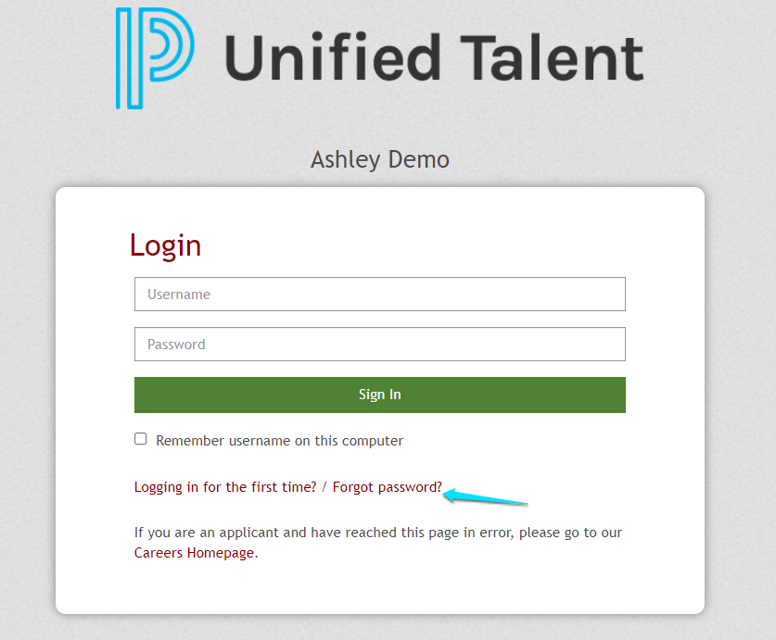

3. Enter the email associated with your account. Because of added security measures, you MUST use the email associated with the account in order for this to work.  
4. This email should be sent within 5 minutes. If you don’t receive it, please check your junk mail and spam folders before contacting your system administrator.

* **NOTE: This reset link will only be valid for 4 hours.**

Example of Reset Password Email

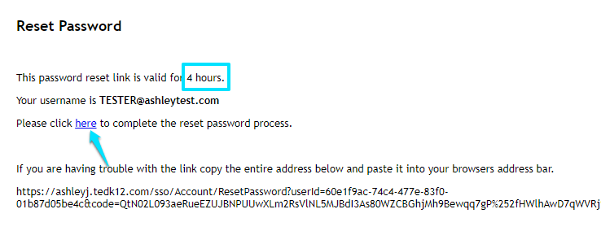

**Password Requirements**: Eight characters minimum, with at least one special character. Spaces are not allowed. No 'greater than' or 'less than' symbols (< or >) are allowed and can result in a 500 error if used.

5. If your password reset does not arrive within an hour, please contact Talent Ed at:

* 866-434-6276
* 855-955-0946
* help.powerschool.com

6. The Human Resources Department is here to support you. You may contact us at 281-229-6016